Time Series Forecast

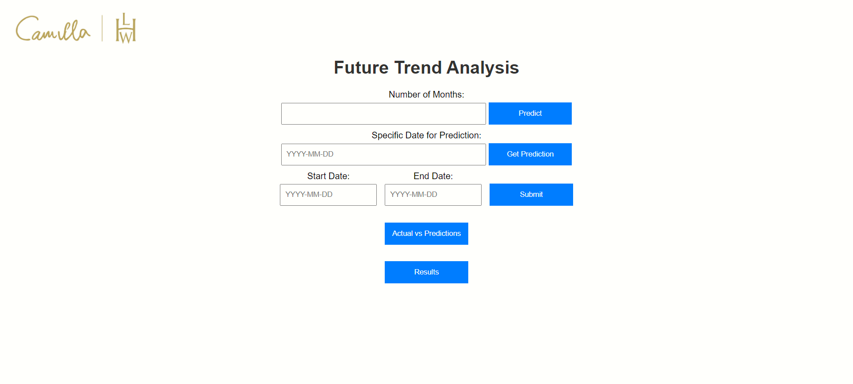

Features:

1. Actual vs Prediction: Contains the prediction of the data that was used for testing. This signifies the accuracy of the model.

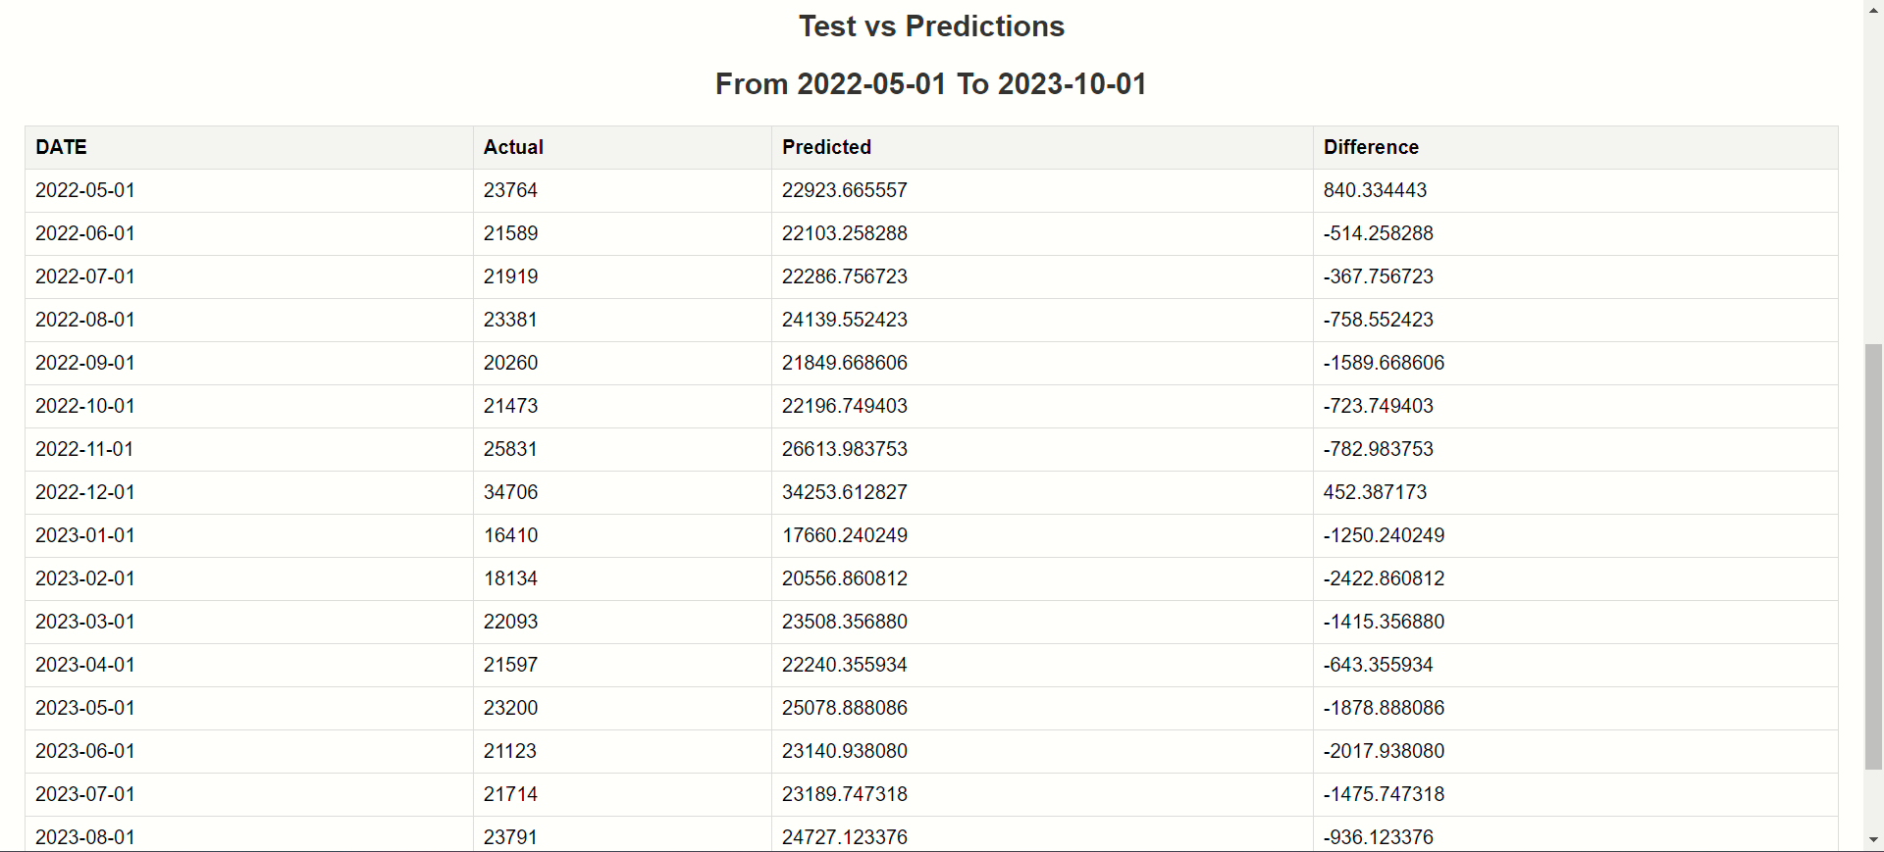

2.Predict: Specify the number of months for which you want the app to predict.

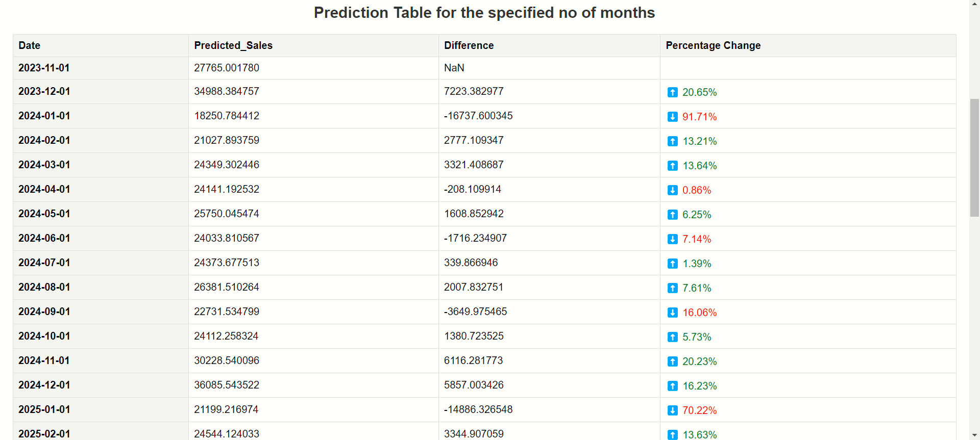

3.Get Prediction: Specify the specific month or date to get the predicted value of that month or date.

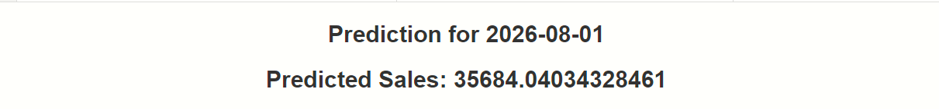

Start Date-End Date: Specify the range of the months for which you want the specific predicted value.

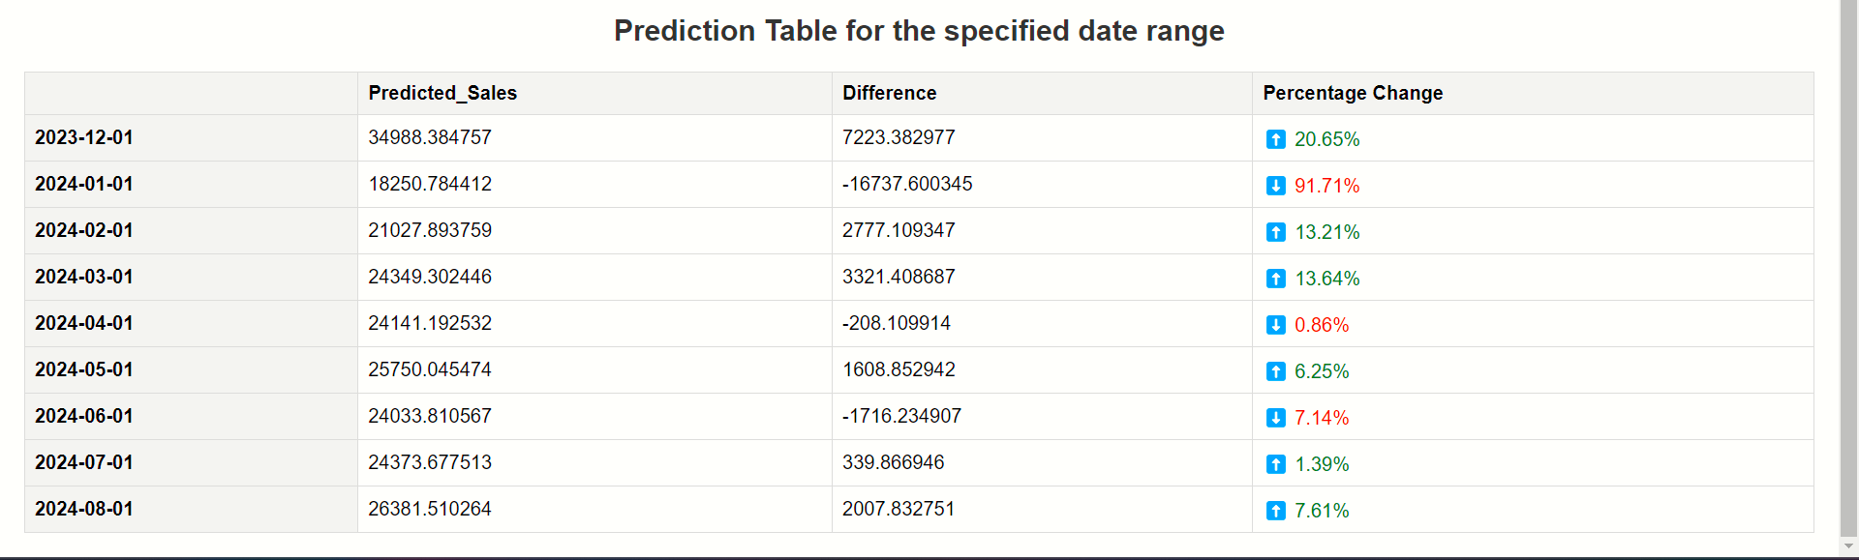

Results: Shows the graphical representation of the predicted values either future prediction or the test data vs actual predicted value.

